### Gameplay introduction

The level includes combat, puzzle, platform and stealth game modes as well as the ability to freely explore the library, discover the mysteries it hides and talk to the ghosts that inhabit it. Furthermore, as already specified, the level is divided into sub-areas which have different goals, different types of gameplay and so on.

#### Exploration mode:

The level is mainly based on the exploration of the game map. The main objective proposed to the player is to find the four seals to open the passage to the restricted section. So much of the level gameplay will be exploring the various rooms, finding a way to access them and retrieve the seals.

#### Dialogue mode:

In the level there is a dialogic component, albeit limited. In the main section there are two NPCs which it is possible to talk with. These characters can give you information about the location of certain objects, they can tell you about their history and the history of the library. In the restricted section Onorius Durandal, the keeper of the library, will question Minerva to understand the reason for her presence. Through the dialogues the player can choose whether to fight or find an alternative to get around him.

#### Combat mode:

In almost all the rooms of the library there are fights with enemies of different dangers. Often the fights are combined with a puzzle component. In the spell book section Minerva must light all the candles in the room to injure the enemy. In this way, the combat alternates between the puzzle phase and the combat phase.

#### Puzzle mode:

As already explained in the combat mode paragraph, the puzzles are combined with the fights in order to provide two different types of challenges. Nevertheless, as there are fights without puzzles, there are isolated puzzles in the various sub-areas of the library.

#### Platform mode:

The level has two zones that Minerva must use the animagus spell to get through. In particular, these areas are the secret passage to the bestiary section and the passage along the ceiling of the library to reach the astronomy section. Also inside the astronomy section there are platform areas.

#### Stealth mode:

After recovering two of the four seals, in the main section the books will animate to identify the intruder. Minerva can avoid ghost-book fights by not being detected. This entails another game mode: stealth mode.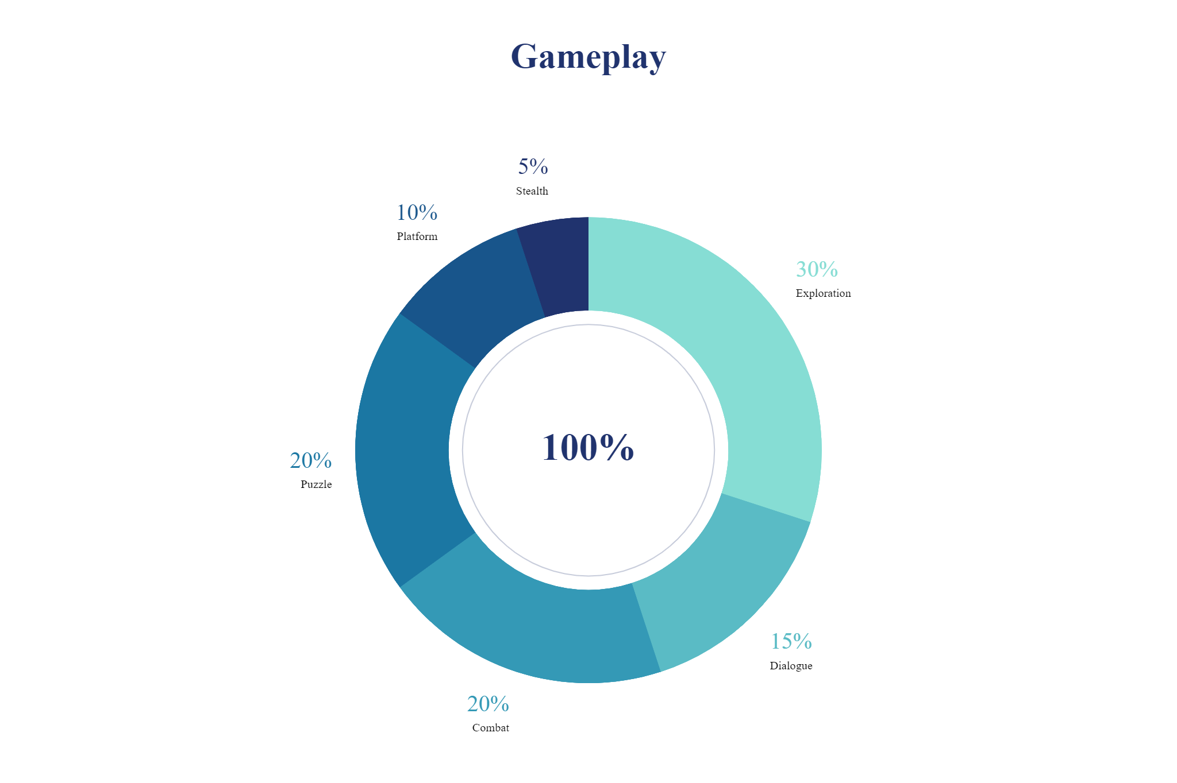

https://spark.adobe.com/express-apps/chart/?authredirect=true#